**Exercise 1: Configuring a Basic Spring Application**

**Main.java**

package org.example;  
  
import org.example.service.BookService;  
import org.springframework.context.ApplicationContext;  
import org.springframework.context.support.ClassPathXmlApplicationContext;  
  
public class Main {  
public static void main(String[] args) {  
ApplicationContext context = new ClassPathXmlApplicationContext("applicationContext.xml");  
  
BookServicebookService = (BookService) context.getBean("bookService");  
  
bookService.addBook("My new book");  
 }  
}

**BookRepository.java**

package org.example.repository;  
  
public class BookRepository {  
public void saveBook(String title) {  
System.*out*.println("Book: " + title + " successfully saved");  
 }  
}

**BookService.java**

package org.example.service;  
  
import org.example.repository.BookRepository;  
  
public class BookService {  
private BookRepositorybookRepository;  
  
public void setBookRepository(BookRepositorybookRepository) {  
this.bookRepository= bookRepository;  
 }  
  
public void addBook(String title) {  
System.*out*.println("Adding book: " + title);  
bookRepository.saveBook(title);  
 }  
}

**applicationContext.xml**

<?xml version="1.0" encoding="UTF-8"?>  
<beans xmlns="http://www.springframework.org/schema/beans"  
xmlns:xsi="http://www.w3.org/2001/XMLSchema-instance"  
xsi:schemaLocation="http://www.springframework.org/schema/beans  
 http://www.springframework.org/schema/beans/spring-beans.xsd">  
  
<bean id="bookRepository" class="org.example.repository.BookRepository"/>  
  
<bean id="bookService" class="org.example.service.BookService">  
<property name="bookRepository" ref="bookRepository"/>  
</bean>  
  
</beans>

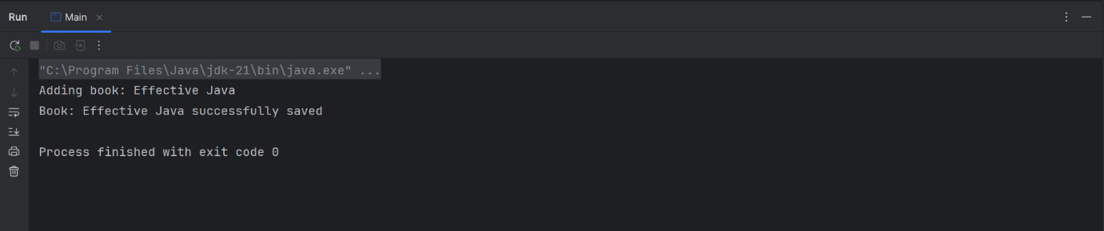

**Exercise 2: Implementing Dependency Injection**

**Main.java**

package org.example;  
  
import org.example.service.BookService;  
import org.springframework.context.ApplicationContext;  
import org.springframework.context.support.ClassPathXmlApplicationContext;  
  
public class Main {  
public static void main(String[] args) {  
ApplicationContext context = new ClassPathXmlApplicationContext("applicationContext.xml");  
  
BookServicebookService = (BookService) context.getBean("bookService");  
  
bookService.addBook("This is another new book");  
 }  
}

**BookRepository.java**

package org.example.repository;  
  
public class BookRepository {  
public void saveBook(String title) {  
System.*out*.println("Book: " + title + " successfully saved");  
 }  
}

**BookService.java**

package org.example.service;  
  
import org.example.repository.BookRepository;  
  
public class BookService {  
private BookRepositorybookRepository;  
  
public void setBookRepository(BookRepositorybookRepository) {  
this.bookRepository= bookRepository;  
 }  
  
public void addBook(String title) {  
System.*out*.println("Adding book: " + title);  
bookRepository.saveBook(title);  
 }  
}

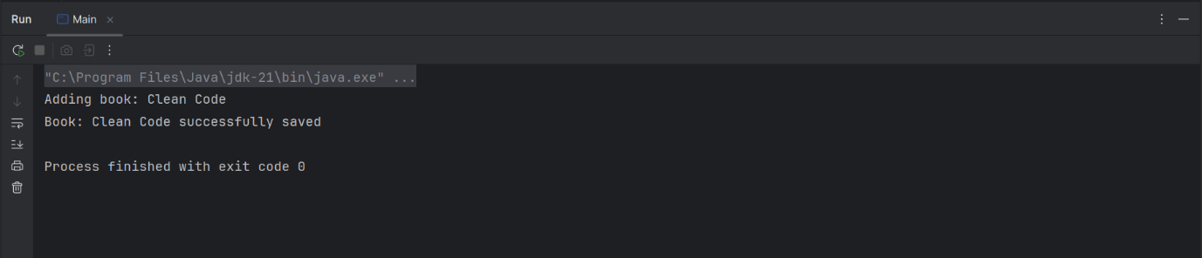

**Exercise 4: Creating and Configuring a Maven Project**

**Pom.xml**

<?xml version="1.0" encoding="UTF-8"?>  
<project xmlns="http://maven.apache.org/POM/4.0.0"  
xmlns:xsi="http://www.w3.org/2001/XMLSchema-instance"  
xsi:schemaLocation="http://maven.apache.org/POM/4.0.0 http://maven.apache.org/xsd/maven-4.0.0.xsd">  
<modelVersion>4.0.0</modelVersion>  
  
<groupId>org.example</groupId>  
<artifactId>LibraryManagement</artifactId>  
<version>1.0-SNAPSHOT</version>  
  
<properties>  
<maven.compiler.source>21</maven.compiler.source>  
<maven.compiler.target>21</maven.compiler.target>  
<project.build.sourceEncoding>UTF-8</project.build.sourceEncoding>  
</properties>  
  
<dependencies>  
  
<dependency>  
<groupId>org.springframework</groupId>  
<artifactId>spring-context</artifactId>  
<version>6.2.8</version>  
</dependency>  
  
<dependency>  
<groupId>org.springframework</groupId>  
<artifactId>spring-aop</artifactId>  
<version>6.2.8</version>  
</dependency>  
  
<dependency>  
<groupId>org.springframework</groupId>  
<artifactId>spring-webmvc</artifactId>  
<version>6.2.8</version>  
</dependency>  
  
<dependency>  
<groupId>javax.servlet</groupId>  
<artifactId>javax.servlet-api</artifactId>  
<version>3.1.0</version>  
</dependency>  
  
  
</dependencies>  
  
<build>  
<plugins>  
<plugin>  
<groupId>org.apache.maven.plugins</groupId>  
<artifactId>maven-compiler-plugin</artifactId>  
<version>3.14.0</version>  
<configuration>  
<source>1.8</source>  
<target>1.8</target>  
</configuration>  
</plugin>  
</plugins>  
</build>  
  
</project>